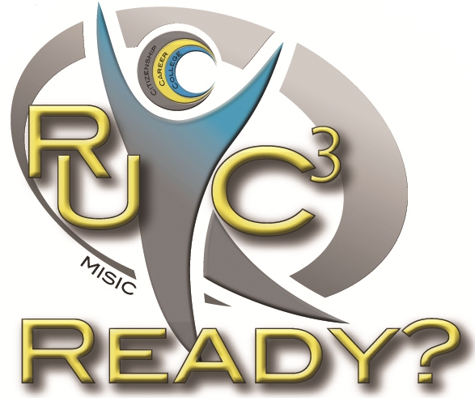
It’s Time to Plan
C3 Cadre
Professional Learning
2018-2019

C3 Cadre provides a focus on Iowa Core unit planning to ready students for college, career, and citizenship.

Dig Deeply
Iowa Core Standards & Learning Targets
Teaching & Learning with Text
Academic Vocabulary & Writing to Learn
Instructional Strategies & Scaffolding
Aligned Assessments

Build Capacity
Teachers & Administrators
Instructional Coaches & Model Teachers
Curriculum Leads & Classroom Teachers

Learning Schedule Possibilities
Summer and First Semester 2018
Released Days throughout the School Year 2018-2019
During scheduled professional development

By April 1 - Contact
Ann Bartelt - annbartelt0204@gmail.com
Amy Walter - amywalter.misic@gmail.com
Becky Hacker Kluver - beckyhackerkluver@gmail.com
Jamie Morgan - jamie@misiciowa.org

