Students at the Center: Personalized Learning with Habits of Mind Curriculum Leadership Academy - April 20-21
Register Now
Iowa ASCD is proud to present the 15th Annual Curriculum Leadership Academy

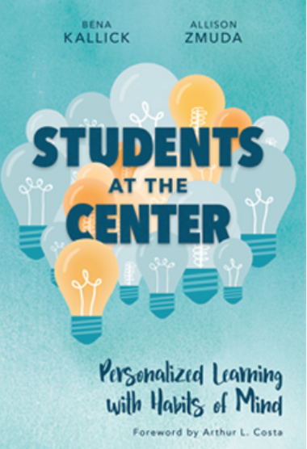
This Academy is designed for you!
- Curriculum Director Principal
- Superintendent Teacher
- Teacher Leader Counselor

Join us on April 20 as we feature Allison Zmuda, co-author with Bena Kallick of Students at the Center: Personalized Learning with Habits of Mind.
On April 21, school districts from across the state of Iowa will share their experiences with personalized learning. Matt Townsley will cap off the day with tips on personalizing standards-based grading.
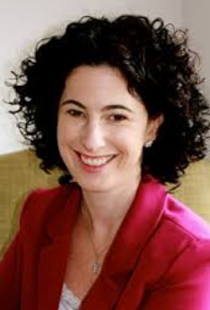
Thursday, April 20:
Allison Zmuda: "Students at the Center - Personalized Learning with Habits of Mind" How do we create meaningful, personalized learning environments that leverage the expertise of teachers and the voices of students to design powerful experiences? Zmuda will focus on the key leverage points to make this happen - clarity of the "Why"; examining existing curriculum, assessment, and instructional practices using the four attributes; and identifying classroom-based and school-based considerations, including but not limited to use of design thinking, student-led conferences, grading and reporting, and school schedules.
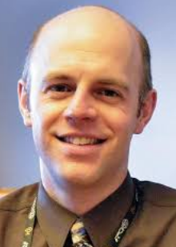

Friday, April 21
Voices of Experience! Examples from the Field!
- Breakout sessions from Iowa schools and colleges will be featured in the morning.
- In the afternoon, Matt Townsley will address "Personalizing Standards-Based Grading in a Competency-Based World." Standards-based grading is spreading across Iowa. The Iowa Department of Education has been facilitating a competency-based education collaborative! Where does personalized learning fit it? Examples and vignettes will frame an interactive keynote presentation clarifying these three big ideas.

Register Now! Join us in Des Moines!
- Members: $250
- Nonmembers: $295 - this includes a complimentary one-year membership to Iowa ASCD, which includes access to 30 books on-line.
- You may register on line at http://iowaascd.org/index.php/events/event-registration/ or you may send a purchase order with names and e-mail addresses of participants to Bridget Arrasmith, Room 123, School of Education at Drake University, 3206 University, Des Moines, IA 50311; Phone: 515.271/2054 or 515.271.1872; FAX: 515.271.2233.
- Des Moines, Iowa Ramada Tropics Resort & Conference Center

