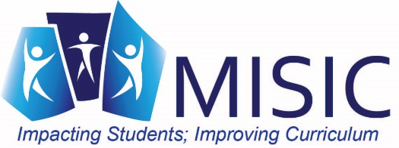
Some Literacy Tools to Consider!!

ELA / Literacy Assessments
Mini-assessments that illustrate the demands of college- and career-ready standards

Academic Word Finder
Find the high-value, tier two vocabulary in any text

Student Writing Samples
Annotated student writing samples illustrating the integration of content understanding and writing in the three types of writing expected by college- and career-ready standards, including the CCSS. There are two types of resources available:
On-Demand Writing provides a progression of writing across grades (K–5 and 6–12); students have written independently to the same text-based prompt across grades.
Range of Writing provides multiple examples of student writing within a grade across a wide variety of content areas, curriculum units, conditions for writing, and purposes.

ELA / Literacy Lessons
Lessons designed to highlight the ELA/literacy Shifts and expectations of college- and career-ready standards

Literacy Design Collaborative offers a framework for building the college-and-career-ready literacy skills specified by the Common Core State Standards. There are modules, lessons and videos to assist teachers in making the instructional shifts demanded in the common core. Provides template tasks to help with writing common core tasks.

Readworks provides reading comprehensions lessons K-6 aligned to CCSS.

ReadWriteThink Engage your students in online literacy learning with these interactive tools that help them accomplish a variety of goals—from organizing their thoughts to learning about language—all while having fun.

Teaching Reading K-12 This video library features the teaching practices of a diverse cross-section of kindergarten through second grade teachers from across the country. The teachers introduce their students to reading through a variety of methodologies. The library includes nine half-hour classroom videos showing teachers and students engaged in effective reading practices; three half-hour longitudinal videos that show individual students developing reading skills over time; and one half-hour library overview.

The Learning Network: Teaching and Learning with the New York Times

English Language Arts Georgia Standards of Excellence (GSE) K-5
Documents similar to the MISIC Literacy Bookmarks – called “Teacher Guidance”

Text Sets: Building Knowledge and Vocabulary
Lessons using a volume of reading on specific topics to support all learners (from Achieve the Core)
CommonLit
Free reading passages and progress tracking tools for grades 5-12.

