HELP Doc
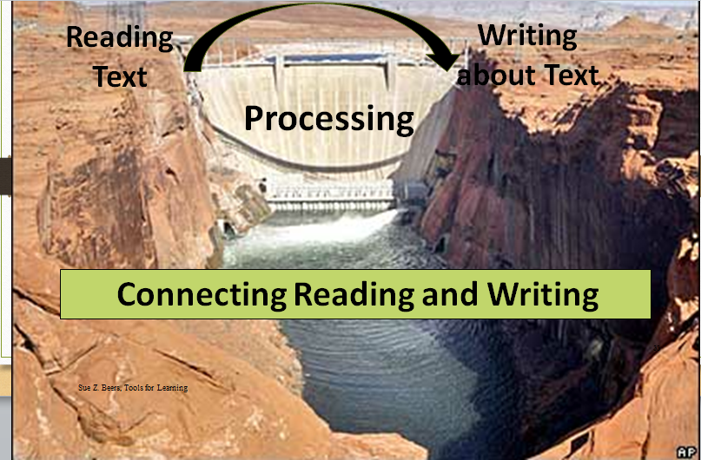
WRITING ASSIGNMENTS

- Writing from Sources: Routinely expects that students draw evidence from texts to produce clear and coherent writing that informs, explains, or makes an argument in various written forms (notes, summaries, short responses, or formal essays). | - Balance of Writing: Includes a balance of on-demand and process writing (e.g. multiple drafts and revisions over time) and short, focused research projects, incorporating digital texts where appropriate. | - Integrates targeted instruction in such areas as grammar and conventions, writing strategies, and fluency (3-12)  - Integrates targeted instruction in multiple areas such as grammar and syntax, writing strategies, discussion rules and aspects of foundational reading. (K-2)
- Have you considered adding one of the forms of writing to this unit? What is the logical fit?  - How will you model the type of writing with your text set selections?  - How will you model finding evidence with your text dependent questions so that students connect evidence with text type?  Note: The goal is that there is a flow to making it happen as students connect reading, viewing, listening, researching to writing as communication. | - Have writing tasks of various lengths been included within the unit?  - Is both on-demand and process writing included in the unit?  - Does the writing enhance the understanding of subject area content and lead students to answers to the essential questions that form the purpose of the unit?  - Has digital, as well as print, text been included as background for the writing that is done?  - Does the text used provide examples of the types of thinking and writing that students will be doing as they complete the writing tasks in this unit, especially if the culminating task is writing?  - What pre-writing activities will be used to prepare students for writing?  - What writing skills must be taught explicitly / directly in order for students to complete the writing tasks with success?  Note: The intent of this criterion is to ensure that students have regular practice with writing. | - How does the unit integrate instruction writing, grammar, discussion rules, and foundational reading?  - Are the integrated areas being assessed formatively? How does the student know they have improved?  Note: The focus is on a natural integration. It is about making the unit better not stuffed. Consider the cognitive load of the unit. Content, evidence, and reasoning always count, but you do not always have to focus on grammar and conventions.
 |  |  | Type
 |  |  | A | E | N | R
Process On Demand | Structure: C/C C/E P/S S/O D N

A= Argument E= Explanatory / Informational N= Narrative R= Research
Structure: C/C = Compare and Contrast C/E = Cause and Effect P/S = Problem/Solution S/O = Sequence/Order D = Description N = Narrative

