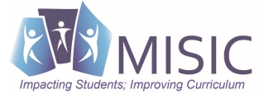
Do You Want This To Be Said of Your Child/Students?

THEY Communicate in Languages Other Than English Yes/No ?

THEY Gain Knowledge and Understanding of Other Cultures Yes/No ?

They Connect with Other Disciplines and Acquire Information Yes/No ?

They Develop Insight into the Nature of Language and Culture Yes/No ?

THEY Participate in Multilingual Communities at Home & Around the World Yes/No ?

Surce: National World Language

