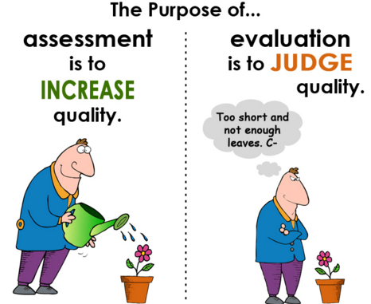
HELP Doc
ASSESSMENT The lesson/unit regularly assesses whether students are mastering standards-based content.
- Elicits direct, observable evidence of the degree to which a student can independently demonstrate the major targeted grade level CCSS standards with appropriately complex text(s). | - Assesses student proficiency using methods that are unbiased and accessible to all students. | - Includes aligned rubrics and/or assessment guidelines that provide sufficient guidance for interpreting student performance. |  |  |  |  | - Uses varied modes of assessment, including a range of pre, formative, summative, and self-assessment measures. |  | - Indicate how students are accountable for independent reading based on student choice and interest to build stamina, confidence and motivation. (May be more applicable across the year or several units).
- Are the assessments that students are asked to do quality demonstrations/ performances that give you confidence that students are getting good at what you really want them getting good at?  - How will formative assessment be sustained throughout the unit?  - Did what you ask them to do in the assignments and tasks that you provided feedback on, really look like what we asked them to be able to do independently at the end of the unit?  Note: Evidence of what students can do may be produced by the assessment, but it may not provide evidence of proficiency of the targeted standards. When developing the unit for this criterion, developers should consider all of the assessment across the entire unit, not only the summative assessment at the end. This is not about looking good, but a true alignment of standards, tasks, and assessment. | - How will students be allowed to show what they have learned?  - How does the unit provide for possible student responses to discussion questions?  - How does the unit/lesson provide teacher and student with exemplars?  - How does the formative and summative exemplar(s) model the standards?  Note: This criterion is about considering the diversity of the students in the classroom. | - How do the assessments describe student expectations (e.g. annotated student work, descriptive rubrics/checklists)?  - How will the unit provide users with clear criteria for interpreting student work as developing toward or mastery of the targeted instruction?  Note: This criterion is about providing clear enough formative feedback and summative scoring criteria with exemplars that both student and teacher understand the expectations. |  |  |  |  | - How will students be provided enough formative assessment opportunities (quality with feedback) to know they are on their way to becoming independent with the learning targets?  Note: The goal is about becoming independent. |  | - How will students be held accountable for independent reading?  - How much time will be devoted to independent reading based on student choice and interest? How will time used for this purpose move students toward attainment of the standards?  - How will confidence and motivation be enhanced through the use of independent reading? What measures will be used to assess these?  Note: This criterion is about supporting the traditional volume of reading that is inferred by the core.
Assessments: |  |  | Function |  |  |  |  | Standards  (targeted standards aligned to the assessments)
 |  |  | P | F | S | SA
P = Pre-Assessment F = Formative S = Summative SA = Self-Assessment

