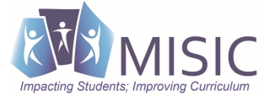

Do You Want This To Be Said of Your Child/Students?

They conceive and develop new artistic ideas and work (create). YES/NO ?

They realize artistic ideas and work throuhg interpretation and presentation (perform). YES/NO ?

They interpret and share artistic work (present). YES/NO ?

They realize and present artistic ideas and work (produce). YES/NO ?

They understand and evaluate how the arts convey meaning (respond). YES/NO ?

They relate artistic ideas and work with personal meaning and external context (connect). YES/NO ?

Source: National Core Arts Standards

