2015 Iowa Core Science
Current Reality:
- Iowa State Board of Education Replaced 2008 Standards by Adopting K-8 grade level and HS grade span Performance Expectations August 6, 2015
- Iowa DE has released a draft Iowa Science Standards Strategic Plan(time, PD, assessment, resources)
- Iowa Core website will need to provide access to corresponding supporting documents for Iowa Science
- Iowa DE working on hiring a new Science Consultant (early August was true)
- Iowa DE and AEA’s training (2 days late September) each AEA science consultant team plus two LEA teachers from each AEA. Basic workshop on how science is about engaging students in Practices, Crosscutting Concepts, and Disciplinary Core Ideas.
- UI, Grandview, and Iowa DE holding Iowa Science Standards Kick-off Oct. 20, 2015. Administrators, curriculum directors, AEA consultants, teacher leaders, and professors will be invited. Event will be streamed live.
- June 15-17, 2016 Summer Symposium on Science Standards.
- Iowa DE working with Achieve to offer webinars on special topics.
- Full implementation in 2018-19 in grades K-5 and HS. MS is grade 6 in 2018-19, grade 7 in 2019-20, etc.
Performance Expectations (PE’s)
Kindergarten | Next Generation Science Standards ‘13 EQUALS the Iowa Core Science ’15
First
Second
Third
Fourth
Fifth
High School Grade Span
Middle School | - Committee had options to go with MS grade span or grade- specific. Went with grade specific.  - Once decision was made to go grade specific than consulted option NGSS Appendix K for guidance. Did not go with the CA integrated example or Course Map II in Appendix K. Final PE’s in Iowa reflect a changed Course Map 1 to fit Iowa due to committee analysis of the curricular load by grade, alignment to math standards, practices, cross-cutting themes and Bloom’s Revised. Achieve.org facilitated this discussion. For full explanation of the process look at pages 21-32 of the Science Standards Review Team Report 2015.

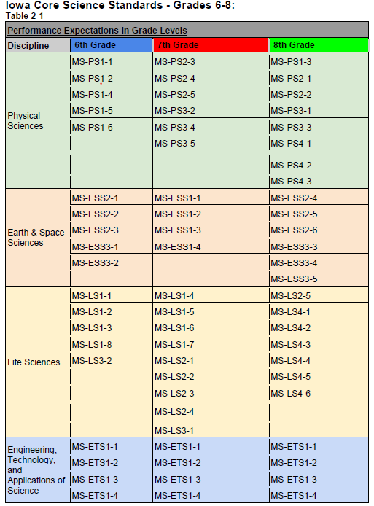
Committee:
- All MS courses of studies begin year with Physics.
- Grade 8 end with Earth Science as a capstone experience.

Integrate not stand alone units

