RESOURCES FOR PARENTS
Common State Standards
http://www.musd.org/commoncore

New Common Core Report Card
http://www.musd.org/reportcards

California Department of Education CCSS Webpage
http://www.cde.ca.gov/re/cc/index.asp

California Smarter Balance Assessments
http://www.cde.ca.gov/ta/tg/sa/index.asp

Assessments to report Understanding of the new expectations
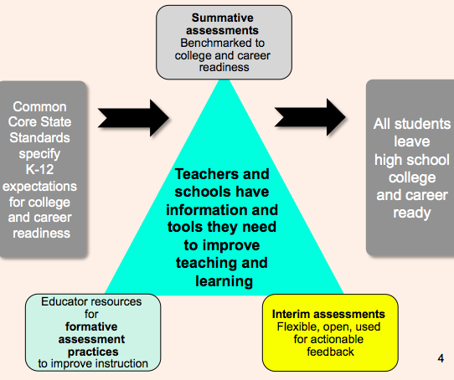

Milpitas Unified School District

133 East Calaveras Blvd.
Milpitas, CA 95035
(408) 635-2600
www.musd.org

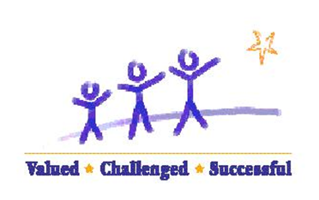

Board of Education
Marsha Grilli, Board President
Daniel Bobay, Board Vice President
Danny Lau, Clerk of the Board
Bill Foulk, Board Member
Gunawan Alisantosa, Board Member

Superintendent
Cary Matsuoka

A Parent Guide to Understanding
Common Core State Standards
Report Card

EDUCATIONAL SERVICES

NEW COMMON CORE STATE STANDARDS REPORT CARDS
Over the course of a year, a team of educators representing each elementary school developed and refined the final draft of our TK-6 grade Standards-Based Report Card.

PURPOSE:
The new report card adheres to the Common Core Standards that our students are expected to achieve.

GOAL:
The goal of the CCSS Report Card is to communicate to our parents, their students’ level of understanding towards the end of the year grade level standards.

CHANGES:
The two new changes in this CCSS Report Card are in the way we mark the English Learner Progress and The Academic Content Standards.

1) ELD English Language Development
- Emerging> Formerly known as Beginning/Early Intermediate
- Expanding> Formerly known as Intermediate
- Bridging> Formerly known as Early Advanced/Advanced

The ELD Standards contain three parts:
- Part I focuses on using language to communicate
- Part II focuses on understanding the structures and grammar of English at a higher level
- Part III focuses on early English Literacy skills

2. Academic Content Standards
- (4) Thorough Understanding > Formerly known as Exceeding the Standards
- (3) Adequate Understanding> Formerly known as Mastery of the Standards
- (2) Partial Understanding > Formerly known as Expected Performance
- (1) Minimal Understanding Formerly known as Area of Concern
- N/A Not Applicable Stays the Same

The expected depth or level of understanding of the grade level Common Core State Standards is measured against the end of the school year proficiency NOT against the end of the trimester proficiency.

What this means…
- Students are evaluated against what they need to “thoroughly understand” by the end of the school year.

- This also means that at the beginning of the school year, most students will demonstrate a minimum to partial understanding and as the year progresses, they would develop a deeper understanding of the content standards.
  - For example, it is unlikely that a 3rd grade student would have fully mastered all of the 3rd grade content by the end of the first trimester but by the end of the school year they should have.

Rationale for these changes
- This decision aligns with genuine “standards based reporting” where students are evaluated against end of the year standards (examples are SBAC, iReady, etc.).

- The SBAC will report student results against end of the year “understanding”. Therefore we must monitor students’ progress towards the end of the year targets and attainment of these rigorous expectations.

- The new Common Core Standards are designed to prepare our students for the real world knowledge and skills they will need for success in both, higher education and careers.

- Effective Spring 2015 we will administer the new Online Smarter Balance Assessment and the results will be used to inform our practices on how we are preparing our students for success.

