The C3 Graduation Table
Quickly determine the high school graduation year for each grade level
School Year a Grade Will Graduate High School

Add 2 years to each number to determine when they would graduate a 2 yr. institution and add 4 yrs. to each number to determine when they would graduate a 4 yr. institution
Grade level | 2014-15 | 2015-16 | 2016-17 | 2017-18 | 2018-19 | 2019-20
PreK | 2028 | 2029 | 2030 | 2031 | 2032 | 2033
K | 2027 | 2028 | 2029 | 2030 | 2031 | 2032
1 | 2026 | 2027 | 2028 | 2029 | 2030 | 2031
2 | 2025 | 2026 | 2027 | 2028 | 2029 | 2030
3 | 2024 | 2025 | 2026 | 2027 | 2028 | 2029
4 | 2023 | 2024 | 2025 | 2026 | 2027 | 2028
5 | 2022 | 2023 | 2024 | 2025 | 2026 | 2027
6 | 2021 | 2022 | 2023 | 2024 | 2025 | 2026
7 | 2020 | 2021 | 2022 | 2023 | 2024 | 2025
8 | 2019 | 2020 | 2021 | 2022 | 2023 | 2024
9 | 2018 | 2019 | 2020 | 2021 | 2022 | 2023
10 | 2017 | 2018 | 2019 | 2020 | 2021 | 2022
11 | 2016 | 2017 | 2018 | 2019 | 2020 | 2021
12 | 2015 | 2016 | 2017 | 2018 | 2019 | 2020

What are different ways you can display HS graduation years?
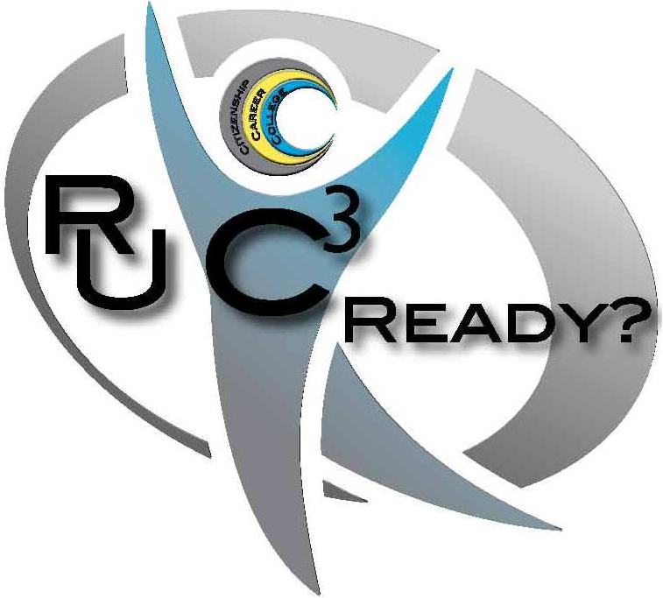
Class photos and bulletin boards
School yearbooks
Posters in hallways and classrooms
Sprit T-shirts
Building and district website
Classroom signage
Photo borders
School supplies
Bookmarks
Assignments (writing, math)

This document was created by MISIC support staff in 2013 for the use by MISIC district members. Permission to reproduce by any MISIC member when authorship cited as http://misiciowa.org
Mid-Iowa School Improvement Consortium (MISIC) PO Box 368, 715 Main Street, Jewell, IA 50130 (office phone-515-827-9010)
MISIC Contact Information at http://misiciowa.org/

High School Graduation Year and Benchmark Years in Future

Use the following chart to illustrate why preparing students for their future in the 21st century is so important. We are not preparing them to live the 21st Century and many will live into the 22nd Century.

Year of HS Graduation for students now enrolled PreK-12 in 2014-15 | Year of 4 year college Graduation | Age 28 in year: | Age 48 in year: | Age 68 in year: | Age 88 in year: | Age 98 in year:
2015 | 2019 | 2025 | 2045 | 2065 | 2085 | 2095
2016 | 2020 | 2026 | 2046 | 2066 | 2086 | 2096
2017 | 2021 | 2027 | 2047 | 2067 | 2087 | 2097
2018 | 2022 | 2028 | 2048 | 2068 | 2088 | 2098
2019 | 2023 | 2029 | 2049 | 2069 | 2089 | 2099
2020 | 2024 | 2030 | 2050 | 2070 | 2090 | 2100
2021 | 2025 | 2031 | 2051 | 2071 | 2091 | 2101
2022 | 2026 | 2032 | 2052 | 2072 | 2092 | 2102
2023 | 2027 | 2033 | 2053 | 2073 | 2093 | 2103
2024 | 2028 | 2034 | 2054 | 2074 | 2094 | 2104
2025 | 2029 | 2035 | 2055 | 2075 | 2095 | 2105
2026 | 2030 | 2036 | 2056 | 2076 | 2096 | 2106
2027 | 2031 | 2037 | 2057 | 2077 | 2097 | 2107
2028 | 2032 | 2038 | 2058 | 2078 | 2098 | 2108

This document was created by MISIC support staff in 2013 for the use by MISIC district members. Permission to reproduce by any MISIC member when authorship cited as http://misiciowa.org
Mid-Iowa School Improvement Consortium (MISIC) PO Box 368, 715 Main Street, Jewell, IA 50130 (office phone-515-827-9010)
MISIC Contact Information at http://misiciowa.org/

